**Q & A for Prescribing of Antidepressants for Depression**

**1. What does the 2025/26 antidepressant prescribing ECF quality indicator include?**

The ECF 2025/26 requires practices to adopt a shared approach for initiating, reviewing and deprescribing antidepressants, in line with national guidance. Practices are required to implement strategies to reduce the risk of unintentional prolonged prescribing of antidepressants by setting clear guidelines on initiation, establishing agreed durations for prescribing, and specifying when and how to discontinue use.

**2. Why is this work being done? What is the evidence to support this work?**

Addressing inappropriate antidepressant prescribing has been identified as a [national medicines opportunity](https://www.england.nhs.uk/long-read/national-medicines-optimisation-opportunities-2023-24/#7-addressing-inappropriate-antidepressant-prescribing) for the NHS in 2024/25.

[OpenPrescribing](https://openprescribing.net/analyse/#org=stp&orgIds=QM7&numIds=4.3&denom=nothing&selectedTab=summary) indicates that the number of antidepressant items prescribed in Hertfordshire and West Essex continue to increase each year.1

Benchmarking data1:

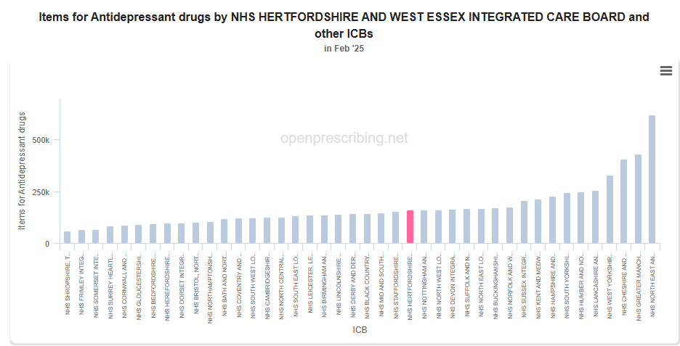

Depression is a common disabling condition, second only to cardiovascular disease. For many people it is a chronic, relapsing condition that can lead to considerable personal disability, lost quality of life for individuals, their family and carers, multiple morbidity, suicide, greater service use and many associated economic costs.2

Antidepressants have an important role in the therapeutic management of depression when used appropriately and in line with the NICE guideline [NG222] [Depression in adults: treatment and management](https://www.nice.org.uk/guidance/ng222).

When a patient and clinician decide withdrawal from an antidepressant is appropriate, in many cases this can be done through gradual discontinuation without major difficulty.2

**3. What should clinicians be considering when starting an antidepressant?**

[NICE guideline NG222 Depression in adults: treatment and management](https://www.nice.org.uk/guidance/ng222/chapter/Recommendations) recommends when offering a person medication for the treatment of depression, discuss and agree a management plan with the person which includes the following3:

* Alternatives to medication
* Ask patients to complete a [PHQ-9 form](https://www.phqscreeners.com/select-screener), for prescribing guidance, BEFORE advising on starting or making changes to antidepressant medication – PHQ-9 forms can be completed at minimum, 2-week intervals.
* The reasons for offering medication.
* The choices of medication (if a number of different antidepressants are suitable), offer medication information leaflet to patient BEFORE commencing treatment, for example, by referring to [HPFT choice and medication](https://www.choiceandmedication.org/hertfordshire) section. Patients can also be supported by using the NHS [Making decisions about managing depression](https://www.england.nhs.uk/wp-content/uploads/2024/09/PRN00675-iv-making-decisions-about-managing-depression.pdf) decision aid.
* The dose, and how the dose may need to be adjusted.
* The benefits, covering what improvements the person would like to see in their life and how the medication may help.
* Discuss potential adverse effects including increased risk of suicide/suicidal thoughts/suicide attempts or clinical worsening in the early stages of recovery during treatment initiation. Discuss other possible side effects (including any side effects they would particularly like to avoid for example, weight gain, sedation, effects on sexual function), and withdrawal effects.
* Any concerns they have about taking or stopping the medication (also see the [recommendations on stopping medication](https://www.nice.org.uk/guidance/ng222/chapter/recommendations#stopping-antidepressant-medication)).
* Make sure they have written information to take away and to review that is appropriate for their needs (see appendix 1).

**4. What should clinicians be considering when stopping an antidepressant?**

[NICE guideline NG222 Depression in adults: treatment and management](https://www.nice.org.uk/guidance/ng222/chapter/Recommendations), states to advise people taking antidepressant medication to **first** **talk** with the person who prescribed their medication (for example, their primary healthcare or mental health professional) if they want to stop taking it. Explain that it is usually necessary to reduce the dose in stages over time (called 'tapering') but that most people stop antidepressants successfully3.

Advise people taking antidepressant medication that if they stop taking it abruptly, miss doses or do not take a full dose, they may have withdrawal symptoms. Also advise them that withdrawal symptoms do not affect everyone and can vary in type and severity between individuals. Symptoms may include3:

* unsteadiness, vertigo or dizziness
* altered sensations (for example, electric shock sensations)
* altered feelings (for example, irritability, anxiety, low mood, tearfulness, panic attacks, irrational fears, confusion, or very rarely suicidal thoughts)
* restlessness or agitation
* problems sleeping
* sweating
* abdominal symptoms (for example, nausea)
* palpitations, tiredness, headaches, and aches in joints and muscles.

**5. What are the key messages for clinicians who undertake a depression review?**

Clinicians should:

* Not routinely offer antidepressant medication as first-line treatment for less severe depression (i.e. PHQ-9 score < 16), as it is found to respond well to non-pharmacological approaches, unless an antidepressant is the person's preference.4
* Consider that for [50% of individuals depressive symptoms](https://rightdecisions.scot.nhs.uk/antidepressants-quality-prescribing-a-guide-for-improvement/key-messages/) can spontaneously resolve within 12 weeks of diagnosis.
* Use the stepped-care approach to help choose the most appropriate intervention - self-help, non-pharmacological, with or without antidepressant therapy.4
* Create the opportunity for people to be directed to and access [non-pharmacological and psychological interventions](https://rightdecisions.scot.nhs.uk/antidepressants-quality-prescribing-a-guide-for-improvement/recommendations-for-healthcare-professionals/non-medicalised-and-non-pharmacological-options-where-appropriate/#accordion-heading-0), which may be needed to achieve better longer-term outcomes.4
* Consider that antidepressants or changes to antidepressants do not need to be made in one appointment - it is prudent for the prescriber to have a discussion with the patient and provide them with medicines information leaflet(s) to go home with and consider their options, including non-pharmacological strategies, lifestyle changes BEFORE starting patient on an antidepressant. This enables **shared decision making and** increases likelihood of adherence.
* Undertake **proactive medicine reviews** particularly those on antidepressants long-term, as often individuals present only at times of crisis, which may lead to inappropriate increased antidepressant dosing, and reduces the opportunity to advise the use of non-pharmacological approaches that may aid in recovery.
* Consider different strategies (such as change in formulation to accommodate dose changes) for reducing, tapering and stopping antidepressants, where indicated and **individualised to patient preferences**.

**6. Which target groups should I prioritise for a review?**

Potential groups of people that receive antidepressants that would benefit from being prioritised for a regular, proactive medicines review4:

* People receiving the same antidepressant continuously, long-term (≥2 years).

#### Older adults (≥65 years) and frail adults.

#### People receiving combinations (antidepressants plus a benzodiazepine or Z-drug or combination antidepressants).

* People receiving [high dose SSRIs](https://rightdecisions.scot.nhs.uk/antidepressants-quality-prescribing-a-guide-for-improvement/target-groups-for-review/high-dose-ssris-for-the-treatment-of-depression/) for the treatment of depression.
* People receiving low dose mirtazapine (15mg) or trazodone (100mg or less) for insomnia or subtherapeutic doses of mirtazapine (<30mg per day) for the treatment of depression.

**7. How often should a patient be reviewed at initiation and ongoing treatment?**

***Initiation***

Review to check for tolerance and symptom improvement within 2 weeks, or **1 week in the under 25-year-olds or those with suicide risk** (consider a face-to-face appointment)**,** and then again as often as needed (but no later than 4 weeks) after initiation.5

***Ongoing Treatment***

For a single depressive episode, ensure patients are advised that treatment might need to be taken for at least 6 months after symptom remission, (those at risk of relapse should continue for at least 2 years).5

Review treatment for people continuing with antidepressant medication to prevent relapse at least every 6 months, although frequency should be based on individual assessments, monitoring5:

* Mood – appetite, sleep, energy.
* For side effects including sexual dysfunction.
* If they wish to stop antidepressant.
* Other causative factors that may affect risk of relapse.

***Deprescribing***

Deprescribing an antidepressant is a **collaborative** process, with the patient and/or their carer, to ensure the safe and effective withdrawal of medicines that are no longer appropriate, beneficial or wanted, **guided by a person-centred approach and shared decision-making.**

Consider scheduling more frequent reviews during occurrence of serious adverse effects. Agree on regular intervals for reviewing and adjusting the reduction schedule as needed for that individual.

To help clinicians and patients to withdraw antidepressants, the Royal College of Psychiatrists has produced information on [stopping antidepressants](https://www.rcpsych.ac.uk/mental-health/treatments-and-wellbeing/stopping-antidepressants)2,6.

**8. How should an antidepressant be switched?**

If a person is taking an antidepressant, ideally at a recognised therapeutic dose, but wishes to switch treatment due to lack of response, adverse effects, or personal preference please refer to [NICE CKS Depression](https://cks.nice.org.uk/topics/depression/management/ongoing-management/#switching-antidepressants) which provides information on how to switch a patient to an alternative antidepressant.7 Other resources also available, please see question 10.

**9. Are there any primary care clinical system searches or Ardens templates available to support with prescribing and reviewing antidepressants?**

**Searches**

**SystmOne EMIS**

 

Yes, there is an Ardens template available for initiation, monitoring and stopping antidepressants (see Appendix 2 and 3)

**10, What resources are available to support with prescribing, reviewing and stopping antidepressants?**

Hertfordshire and West Essex ICB, [Depression Care Pathway](https://www.hweclinicalguidance.nhs.uk/all-clinical-areas-documents/download?cid=2386&checksum=e258918e86a8fdcdbb466f041f99720e&document=22&field=1)

[Overview | Medicines associated with dependence or withdrawal symptoms: safe prescribing and withdrawal management for adults | Guidance | NICE](https://www.nice.org.uk/guidance/ng215)

[NICE CKS Depression](https://cks.nice.org.uk/topics/depression/management/ongoing-management/#switching-antidepressants)

Royal College of Psychiatrists, [Stopping antidepressants](https://www.rcpsych.ac.uk/mental-health/treatments-and-wellbeing/stopping-antidepressants)

Specialist Pharmacist Service (2023), [Deprescribing of antidepressants for depression and anxiety](https://www.sps.nhs.uk/articles/deprescribing-of-antidepressants-for-depression-and-anxiety/)

HPFT, [Guidelines on Choice and Selection of Antidepressants for the Management of Depression](https://www.hpft.nhs.uk/media/azlh5shc/hpft-guidelines-on-choice-and-selection-of-antidepressants-for-the-management-of-depression-v20-final-feb-2025.pdf)

[Healthcare Improvement Scotland-Right Decision service Antidepressants: Quality prescribing - a guide for improvement](https://rightdecisions.scot.nhs.uk/antidepressants-quality-prescribing-a-guide-for-improvement/)

PH9 questionnaire [PHQ screeners](https://www.phqscreeners.com/select-screener)

EPUT, [Handy Fact Sheet Coming Off Antidepressants](https://www.choiceandmedication.org/eput/generate/handyfactsheetstoppingantidepressantsuk.pdf)

**References**

1. [OpenPrescribing](https://openprescribing.net/analyse/#org=stp&orgIds=QM7&numIds=4.3&denom=nothing&selectedTab=summary)
2. [National medicines optimisation opportunities 2024/25](https://www.england.nhs.uk/long-read/national-medicines-optimisation-opportunities-2023-24/#7-addressing-inappropriate-antidepressant-prescribing) (([Horowitz et al, 2023](https://www.ncbi.nlm.nih.gov/pmc/articles/PMC9911477/)).
3. [NICE guideline NG222 Depression in adults: treatment and management](https://www.nice.org.uk/guidance/ng222/chapter/Recommendations)
4. [Healthcare Improvement Scotland-Right Decision service Antidepressants: Quality prescribing - a guide for improvement](https://rightdecisions.scot.nhs.uk/antidepressants-quality-prescribing-a-guide-for-improvement/)
5. [Guidelines on Choice and Selection of Antidepressants for the Management of Depression V2.0](https://gbr01.safelinks.protection.outlook.com/?url=https%3A%2F%2Fwww.hpft.nhs.uk%2Fmedia%2Ffebdl2cr%2Fhpft-guidelines-on-choice-and-selection-of-antidepressants-for-the-management-of-depression-v20.pdf&data=05%7C02%7Cpaulami.shah1%40nhs.net%7Ccaf743ff447f43905df708dd66ea70b4%7C37c354b285b047f5b22207b48d774ee3%7C0%7C0%7C638779879273687197%7CUnknown%7CTWFpbGZsb3d8eyJFbXB0eU1hcGkiOnRydWUsIlYiOiIwLjAuMDAwMCIsIlAiOiJXaW4zMiIsIkFOIjoiTWFpbCIsIldUIjoyfQ%3D%3D%7C0%7C%7C%7C&sdata=4t%2FUfCQob28boqKyg0tbgeg7hAuSFDlVrcmSE%2FzUCmc%3D&reserved=0)
6. [Royal College of Psychiatrists stopping antidepressants](https://www.rcpsych.ac.uk/mental-health/treatments-and-wellbeing/stopping-antidepressants)
7. [NICE CKS Depression](https://cks.nice.org.uk/topics/depression/management/ongoing-management/#switching-antidepressants)

|  |  |
| --- | --- |
| **Version** | 1.0 |
| **Developed by** | Ashik Shah, Shikha Tatla - Pharmaceutical Advisors, Pharmacy and Medicines Optimisation Team, Hertfordshire and West Essex Integrated Care Board |
| **Approved by** | Medicines Optimisation Delivery and Implementation Group May 2025 |
| **Date approved /updated** | May 2025 |
| **Review date** | The recommendations in this document are based upon the information available at the time of publication. |

**Appendix 1**

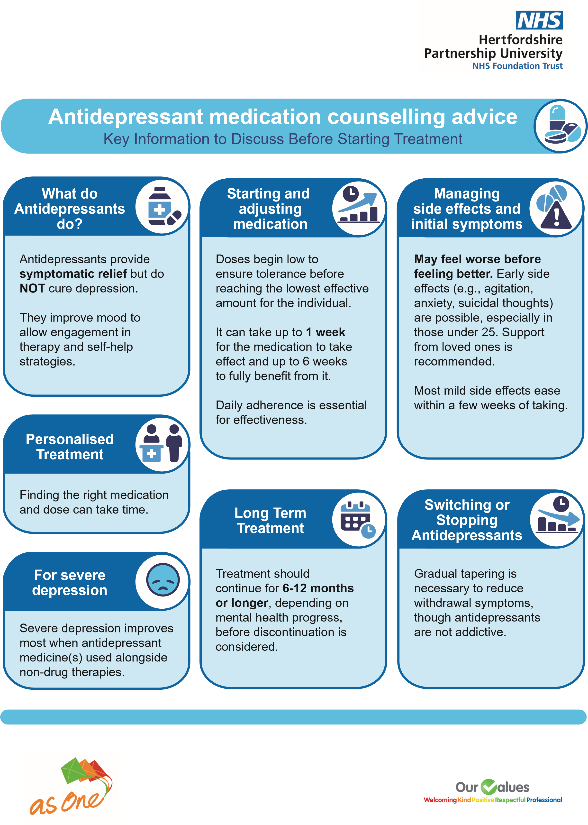

**Appendix 2**

**SystmOne Antidepressant Monitoring Ardens Template**

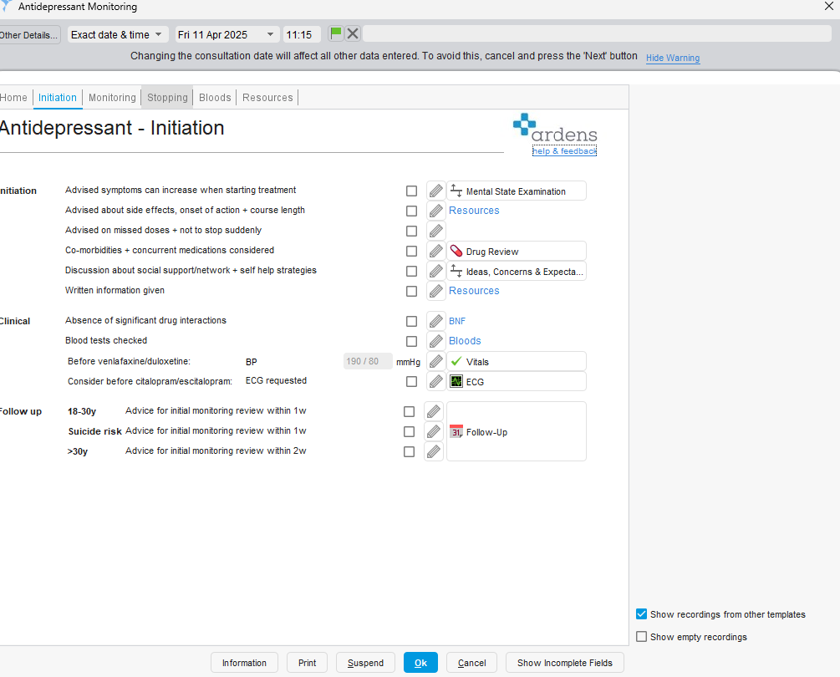

**Appendix 3**

**EMIS Depression Review Ardens Template**

