Pancreatic Enzyme Replacement Therapy (PERT) – For Community Pharmacy
Shortage information and useful actions
Actions for clinicians and prescribers of PERT to be completed by 31/01/2025 and to remain in place only until the supply issues have resolved (see Specialist Pharmacy Service (SPS) Medicine Supply Tool for approximate resolution dates):

1. Clinicians should continue to follow the actions set out in the National Patient Safety Alert issued in May and December 2024.

2. NHS provider trust pharmacy procurement teams should ensure that where quantities greater than current demand are required, unlicensed imports should be considered. ¹

3. To ensure that patients are not left without PERT, Integrated Care Boards (ICBs) should:

a. put in place a local mitigation plan for instances when patients are unable to obtain stock from their community pharmacy or dispensing GP.

b. cascade any local management plan to all community pharmacies and GP practices within the region, as well as local trust pharmacy teams.
CAS-ViewAlert: The alerts received in May and December 2024 are safety critical and complex National Patient Safety Alerts. Implementation should be co-ordinated by an executive lead and supported by clinical leaders in pharmacy, community pharmacy, GP practices, and clinical leaders in respiratory, pancreatology, pancreatic surgery, dietetics and cancer.

There are limited supplies of pancreatic enzyme replacement therapies (PERT):
• Creon® 10,000 gastro-resistant capsules (Viatris UK Healthcare Ltd) , Creon® 25,000 gastro-resistant capsules (Viatris UK Healthcare Ltd) and Creon Micro Pancreatin 60.12mg gastro-resistant granules remain in limited supply until 2026. Pancrex V® 125mg capsules are currently out of stock without a supply date and the 340mg capsules and oral powder is available however unable to fully support an uplift in demand.
• Nutrizym® 22 capsules and are intermittently available but are unable to supply a significant increase in demand.
Please note: Patients must not be left without any PERT. This can lead to hypoglycaemia, severe bowel symptoms, poor absorption of other medications and weight loss.
The supply disruption of Creon® capsules is due to limited availability of raw ingredients and manufacturing capacity constraints to produce volumes needed to meet demand. There are currently intermittent deliveries to wholesalers, however, the volumes are insufficient to meet full demand. Therefore, out of stock periods continue between each delivery. A dedicated Creon team helpline is available on 0800 808 6410 to provide locations where stock is likely to be available. From March 2025 Alliance Healthcare became the sole distributor of Creon.
Unlicensed imports of Creon® capsules and alternative brands of PERT can be sourced, lead times vary . Imported Pangrol® is available via Oxford Pharmacy Store (OPS), which specialist teams in HWE ICS have confirmed is a clinically equivalent brand to Creon®.

Recommendations for community pharmacy:
- Advise patients to order prescriptions 2 weeks ahead of need.
- Pharmacists presented with a repeat prescription for PERT should only supply the equivalent to one month’s supply in accordance with the Serious Shortage Protocols SSP060 and SSP061.

- Check if it is possible to order licensed products (by contacting AAH, Alliance and Phoenix wholesalers as availability may fluctuate).
- Patients are generally advised to check stock in other pharmacies, and the PCN WhatsApp group can also be used for this purpose. However, with specialist medicines like Creon®, this may be more difficult.
- If the patients’ PERT preparation is showing as out of stock, it is recommended that it is added onto the back-order list.
- If you cannot get the licensed product required, let the prescriber know if you can obtain alternative licensed products (Nutrizym® 22 and Pancrex V®, if available) as options for the prescriber to make the appropriate clinical decision for a new prescription with new dosage advice (see table on page 3 below and SPS and the SPS Medicines Supply Tool).
- If no licensed alternatives are available, contact the GP for the unlicensed alternative Pangrol® which is available from Oxford Pharmacy Store. If stock is not available ask the patient or GP to contact their specialist team.
- Endorsing the Prescription (as a non-Part VIIIB special)
Make sure any Pangrol® scripts are endorsed with the following information:
- Amount dispensed over pack size (200) used;
- Invoice price per pack size from which the order was supplied less any discount
- Make sure to include delivery cost
- Manufacturers’/importers’ (Target Healthcare) MHRA licence number which is; MS43086/ WDA(H)43086
- Batch number of the product supplied and “SP”.
- Advise patient to contact prescriber or specialist if experiencing any problems taking Pangrol®

Please refer to NHS BSA guidance: https://faq.nhsbsa.nhs.uk/knowledgebase/article/KA-03292/en-us

How to set up an account with Oxford Pharmacy Store:

Fill in the registration form on the following link and follow the instructions on the webpage:
Oxford Pharmacy Store Register for a New Account : Oxford Pharmacy Store.
For any queries their contact number is: 01865 904 141 or email ops.orders@oxfordhealth.nhs.uk

For guidance on ordering and prescribing unlicensed imports see here.
Community Pharmacy England provide practical advice on the supply of unlicensed PERT preparations.

Product Comparisons: To calculate the new correct dosing regime see SPS website: Find PERT alternatives and equivalences
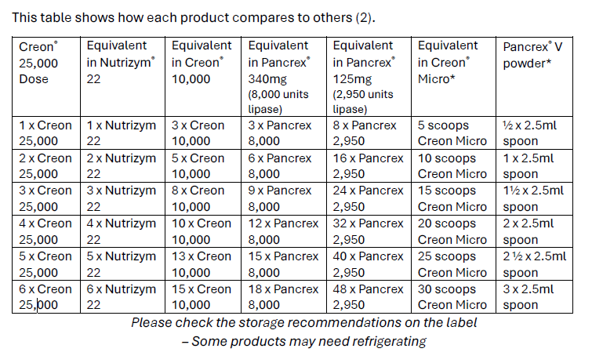
Comparison Table for Pangrol® and Creon®
Specialist teams in HWE ICS have confirmed Pangrol® is a clinically equivalent brand to Creon®.
 |  | Lipase /Ph Eur. Units | Amylase / Ph Eur. units | Protease / Ph Eur. units
Creon 10,000 | Each capsule contains brown/clear gastro-resistant mini microspheres containing porcine pancreatin equivalent to: | 10,000 | 8,000 | 600
Pangrol 10,000 | Each gastro-resistant hard capsule (enteric coated mini tablets) contains 75.6-137.4mg porcine pancreatic powder, equivalent to: | 10,000 | ≥9,000 | ≥500
Creon 25,000 | Each capsule contains brownish mini microspheres containing porcine pancreatin PhEur 300 mg, equivalent to: | 25,000 | 18,000 | 1,000
Pangrol 25,000 | Each gastro-resistant hard capsule contains 188.9-343.5 mg porcine pancreas powder, equivalent to: | 25,000 | ≥22,500 | ≥1,250
Advice for special patient populations
Paediatric, neonatal and cystic fibrosis patients should continue to liaise with their specialist teams for advice about disease management in pancreatic insufficiency and PERT regimens. The Neonatal & Paediatric Pharmacy Group has recently published their own position statement on the shortage of PERT. It aims to provide practical advice on using alternative products, dosing equivalences, and prescribing guidance. The Pancreatic Society has also provided a PERT position statement for patients.
Pancreatic Enzyme Replacement Therapy (PERT)
Patient Flow Chart
Your medication - Herts and West Essex ICS

PERT is prescribed for the treatment of pancreatic exocrine insufficiency such as in cystic fibrosis, pancreatic cancer and pancreatitis. There is no clinical alternative to PERT. Each preparation contains different amounts of pancreatic enzymes. You may have been advised how to adjust your dose according to your symptoms and if problems with digestion or weight loss occur.

Submit your requests for a repeat prescription of PERT two weeks in advance of need

If your regular community pharmacy has no stock of the brand you require and is unable to source any for you and other pharmacies have been contacted

Contact the Creon® helpdesk (0800 808 6410) for Creon® related queries and advice on locations with stock availability in your area based on delivery dates (note – they cannot guarantee that specific pharmacies will have stock)

Alternative not available:
Contact your hospital specialist team or GP (if your hospital specialist is unknown to you) for further advice and a one month supply
If an alternative brand or unlicensed Pangrol® is available, your community pharmacist will contact your GP for a new prescription of a similar product. This may have a different dose.

We are working closely with our hospitals to regularly monitor their stock levels.

Useful links:
SPS: Shortage of Creon 10000 and 25000 gastro-resistant capsules
SPS: Prescribing and ordering available pancreatic enzyme replacement therapies
SPS: Find PERT alternatives and equivalences
Information about the supply of Creon, Nutrizym and Pancrex - Pancreatic Cancer UK
Position Statement: Pert Shortage | Pancreatic Society of Great Britain and Ireland
Creon supply update Cystic Fibrosis Trust
Guts UK - committed to fighting all digestive diseases
Information about the supply of Creon, Nutrizym and Pancrex - Pancreatic Cancer UK
Supply of unlicensed PERT preparations - Community Pharmacy England
Oxford Pharmacy Store Register for a New Account : Oxford Pharmacy Store
Creon 25000 Capsules - Summary of Product Characteristics (SmPC) - (emc) | 1168
Creon 10000 Capsules - Summary of Product Characteristics (SmPC) - (emc) | 1167
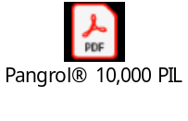

The supply issue is impacting primary care suppliers to a much greater extent than secondary care suppliers due to the supply channels available to each sector. This is increasing pressure on secondary care supplies as some patients unable to obtain stock locally are being referred to local secondary care supplier.

