Pancreatic Enzyme Replacement Therapy (PERT) – For General Practice
Shortage information and useful actions
Actions for clinicians and prescribers of PERT to be completed by 31/01/2025 and to remain in place only until the supply issues have resolved (see Specialist Pharmacy Service (SPS) Medicine Supply Tool for approximate resolution dates):

1. Clinicians should continue to follow the actions set out in the National Patient Safety Alert issued in May and December 2024.

2. NHS provider trust pharmacy procurement teams should ensure that where quantities greater than current demand are required, unlicensed imports should be considered. ¹

3. To ensure that patients are not left without PERT, Integrated Care Boards (ICBs) should:

a. put in place a local mitigation plan for instances when patients are unable to obtain stock from their community pharmacy or dispensing GP.

b. cascade any local management plan to all community pharmacies and GP practices within the region, as well as local trust pharmacy teams.
CAS-ViewAlert: The alerts received in May and December 2024 are safety critical and complex National Patient Safety Alerts. Implementation should be co-ordinated by an executive lead and supported by clinical leaders in pharmacy, community pharmacy, GP practices, and clinical leaders in respiratory, pancreatology, pancreatic surgery, dietetics and cancer.

There are limited supplies of pancreatic enzyme replacement therapies (PERT):
• Creon® 10,000 gastro-resistant capsules (Viatris UK Healthcare Ltd), Creon® 25,000 gastro-resistant capsules (Viatris UK Healthcare Ltd) and Creon Micro Pancreatin 60.12mg gastro-resistant granules remain in limited supply until 2026. Pancrex V® 125mg capsules are currently out of stock, without a supply date and the 340mg capsules and oral powder is available however unable to fully support an uplift in demand.
• Nutrizym® 22 capsules are intermittently available but are unable to supply a significant increase in demand.
Please note: Patients must not be left without any PERT. This can lead to hypoglycaemia, severe bowel symptoms, poor absorption of other medications and weight loss.
The supply disruption of Creon® capsules is due to limited availability of raw ingredients and manufacturing capacity constraints to produce volumes needed to meet demand. There are currently intermittent deliveries to wholesalers, however, the volumes are insufficient to meet full demand. Therefore, out of stock periods continue between each delivery. A dedicated Creon team helpline is available on 0800 808 6410 to provide locations where stock is likely to be available. From March 2025 Alliance Healthcare became the sole distributor of Creon.
Unlicensed imports of Creon® capsules and alternative brands of PERT can be sourced, lead times vary . Imported Pangrol® is available via Oxford Pharmacy Store and is an clinically equivalent brand to Creon®.

Actions for GP practices:
- Prescribe a maximum of one month’s supply of PERT for all patients at a time.
- Issue repeat prescriptions ahead of patients need – consider contacting patients taking PERT to advise them to order 2 weeks ahead of need to allow time for prescriptions to be filled and to share the patient information link.
- Ensure that prescriptions for PERT are generated on a separate script and print out or document the bar code token for the patient to take to the pharmacy. Please remember to send it as a separate prescription for patients without a pharmacy nomination (so that they can get this item dispensed at any pharmacy if required).
- If no licensed Creon® is available, consider switching to alternative licensed products (Nutrizym® 22 and Pancrex V®- if available) using the dosage advice on the SPS website and page 3 below and check SPS Medicines Supply Tool for stock updates.
- Unlicensed and imported Pangrol® is a cost effective alternative brand to Creon®, however should only be prescribed where there is no other licenced alternative available. Further information is provided below.
- Use ‘advice and guidance’ to contact the relevant specialist for advice if no licensed/unlicenced alternatives are available (see note above about Pangrol® as an alternative to Creon®) and if a patient’s supply will run out in the next 10 days. The patient should be informed of this and if no alternative treatments are available the specialist will arrange for a one month supply from their acute trust including unlicensed imports if needed.

Prescribing an unlicensed or imported PERT products including Pangrol®
• Unlicensed and imported Pangrol® (ordered via Oxford Pharmacy Store) is an alternative brand to Creon®, which specialist teams in HWE ICS have confirmed is clinically equivalent to Creon®. It is available in pack sizes of 200 capsules as either 10,000 or 25,000 in strength. The lead time for delivery of Pangrol® to pharmacy is usually 1-2 business days. It is the cheapest imported alternative currently available.
• Liaise with the community pharmacy where an imported PERT product (Pangrol) is required.
• Some unlicensed PERT products including Pangrol® are mapped on the NHS Dictionary of Medicines and Devices (DM+D). These can be sent via EPS.
• Where the unlicensed import PERT product is not mapped on DM+D, it must be issued on a paper FP10 prescription.
• Licensed products should continue to be prescribed via EPS.
• Patients must be informed of the rationale for the use of an unlicensed imported product. Justification for doing so must be documented in the patient’s medical records.

Prescriptions for unlicensed / imported PERT products (including Pangrol®) must contain the following information:
o Name of medication including strength and formulation (imported)
o Special order
o Dosage instructions for the patient
o Quantity

Product Comparisons: To calculate the new correct dosing regime see SPS website: Find PERT alternatives and equivalences
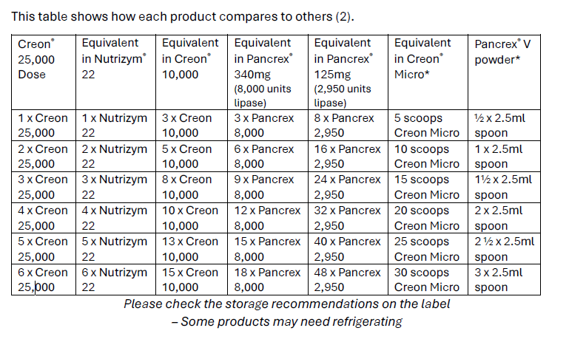
Comparison Table for Pangrol and Creon
Specialist teams in HWE ICS have confirmed Pangrol® a clinically equivalent brand to Creon®
 |  | Lipase /Ph Eur. Units | Amylase / Ph Eur. units | Protease / Ph Eur. units
Creon 10,000  Each capsule contains brown/clear gastro-resistant mini microspheres, containing porcine pancreatin equivalent to |  | 10,000 | 8,000 | 600
Pangrol 10,000  Each gastro-resistant hard capsule (enteric coated mini tablets) contains 75.6-137.4mg porcine pancreatic powder, equivalent to |  | 10,000 | ≥9,000 | ≥500
Creon 25,000  Each capsule contains brownish mini microspheres containing porcine pancreatin PhEur 300 mg, equivalent to |  | 25,000 | 18,000 | 1,000
Pangrol 25,000  Each gastro-resistant hard capsule contains 188.9-343.5 mg porcine pancreas powder, equivalent to |  | 25,000 | ≥22,500 | ≥1,250

Advice for special patient populations
Paediatric, neonatal and cystic fibrosis patients should continue to liaise with their specialist teams for advice about disease management in pancreatic insufficiency and PERT regimens. The Neonatal & Paediatric Pharmacy Group has recently published their own position statement on the shortage of PERT. It aims to provide practical advice on using alternative products, dosing equivalences, and prescribing guidance. The Pancreatic Society has also provided a PERT position statement for patients.

Pancreatic Enzyme Replacement Therapy (PERT)
Patient Flow Chart
Your medication - Herts and West Essex ICS

PERT is prescribed for the treatment of pancreatic exocrine insufficiency such as in cystic fibrosis, pancreatic cancer and pancreatitis. There is no clinical alternative to PERT. Each preparation contains different amounts of pancreatic enzymes. You may have been advised how to adjust your dose according to your symptoms and if problems with digestion or weight loss occur.

Submit your requests for a repeat prescription of PERT two weeks in advance of need

If your regular community pharmacy has no stock of the brand you require and is unable to source any for you and other pharmacies have been contacted

Contact the Creon® helpdesk (0800 808 6410) for Creon® related queries and advice on the locations with stock availability in your area based on delivery dates (note – they cannot guarantee that specific pharmacies will have stock)

Alternative not available:
Contact your hospital specialist team or GP (if your hospital specialist is unknown to you) for further advice and a one month supply
If an alternative brand or unlicensed Pangrol® is available, your community pharmacist will contact your GP for a new prescription of a similar product. This may have a different dose.

We are working closely with our hospitals to regularly monitor their stock levels.

Useful links:
SPS: Shortage of Creon 10000 and 25000 gastro-resistant capsules
SPS: Prescribing and ordering available pancreatic enzyme replacement therapies
SPS: Find PERT alternatives and equivalences
Position Statement: Pert Shortage | Pancreatic Society of Great Britain and Ireland
Guts UK - committed to fighting all digestive diseases
Information about the supply of Creon, Nutrizym and Pancrex - Pancreatic Cancer UK
Position Statement: Pert Shortage | Pancreatic Society of Great Britain and Ireland
Creon supply update Cystic Fibrosis Trust
Guts UK - committed to fighting all digestive diseases
Information about the supply of Creon, Nutrizym and Pancrex - Pancreatic Cancer UK
Supply of unlicensed PERT preparations - Community Pharmacy England
Oxford Pharmacy Store Register for a New Account : Oxford Pharmacy Store
Creon 25000 Capsules - Summary of Product Characteristics (SmPC) - (emc) | 1168
Creon 10000 Capsules - Summary of Product Characteristics (SmPC) - (emc) | 1167
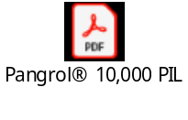

The supply issue is impacting primary care suppliers to a much greater extent than secondary care suppliers due to the supply channels available to each sector. This is increasing pressure on secondary care supplies as some patients unable to obtain stock locally are being referred to local secondary care supplier.

