Continuous Glucose Monitoring for Paediatrics: Position statement
v3.1 March 2026
1. Introduction
People with diabetes on insulin need to regularly monitor their blood glucose levels to judge the amount of insulin they need to inject, to keep their blood glucose within an acceptable range and reduce the risk of short- and long-term complications.
Historically, there were three main types of blood glucose monitoring: self-monitored blood glucose testing (using skin prick tests), real-time continuous glucose monitoring (rtCGM) and intermittently scanned continuous glucose monitoring (isCGM). isCGM is also sometimes known as ‘flash’.
CGM devices can be divided into "low-cost” and "high-cost”. Low-cost CGM are those which cost <£1000 and are usually available to prescribe via a FP10. Formulary choices include FreeStyle Libre 2 plus and Dexcom ONE+. These devices have sufficient functionality to meet the needs of most patients requiring CGM (see appendix 1).
Higher cost CGM devices >£1000 on the formulary include Freestyle Libre 3, Dexcom G6 & G7, Medtronic 3 & 4. These have additional functionality which is appropriate for selected groups of patients. (see appendix 2) Freestyle Libre 3 can now be upgraded to the FreeStyle Libre 3 plus which offers even more functionality.
This guidance update adds eligibility criteria for each of the different high cost CGM devices available locally, to ensure that the most cost-effective, clinically appropriate device is selected.

2. Content
The following cohorts of children and young people are eligible for CGM
- All children and young people with type 1 diabetes are currently recommended for funding for specific CGM devices in HWE (As per the latest NICE guidance NG18 2022,
- Children and young people with insulin treated type 2 diabetes who are living with a learning disability, and it is recorded on their GP Learning Disability register (As per NHSE 2019 Flash guidance,)
- Children and young people with any form of diabetes on haemodialysis and on insulin treatment who are clinically indicated as requiring intensive monitoring >8 times daily, as demonstrated on a meter download/review over the past 3 months (As per NHSE 2019 Flash guidance,)
- Children and young people with diabetes associated with cystic fibrosis on insulin treatment (As per NHSE 2019 Flash guidance)
CGM devices will be offered, alongside education to support CYP and their families and carers to use it.
A summary on process for initiation and supply of low cost CGM has been added as appendix 3.
The Dexcom ONE+ and FreeStyle Libre 2 plus have sufficient functionality to meet the needs of many children requiring CGM. Both have customisable hypoglycaemia alerts, supporting those with impaired hypoglycaemia awareness. They are both able to do repeat hypoglycaemia alerts (e.g. if hypoglycaemia continues or reoccurs).
The Freestyle Libre 2 plus is an upgrade to the Freestyle Libre 2. It continues to allow data sharing. The sensors have 15 day wear (opposed to 14) and can link with specific insulin pumps to form a hybrid closed loop system.
The Dexcom One + is an upgrade to the Dexcom One. It allows data sharing for up to 10 followers, has one-touch sensor applicator with a 30-minute warm up, no separate transmitter, it’s 60% smaller and offers a 12-hour grace period before a sensor must be changed. It is intended as a standalone CGM and does not have the ability to be used for hybrid closed loop systems.
Initiation of CGM is via specialist diabetes teams only. Blueteq application forms are no longer required for low-cost CGM. At initiation clear communication should be sent to primary care via clinic letters. Patients will be regularly reviewed by the specialists to ensure they are benefiting from CGM. If there are any changes these should be communicated to primary care. The low-cost CGM devices, following initiation by the specialists, can be prescribed via FP10 in primary care.
Where a patient requires high cost CGM an application is required via the Blueteq drug management system.
See Appendix 1 for a comparison document for formulary CGM devices that are available on FP10.

- Switching between low-cost CGM manufacturers
Patients currently receiving NHS-funded low-cost CGM who feel that an alternative manufacturer’s system is better suited to managing their diabetes should be advised to discuss this with their diabetes specialist at their next routine appointment. Specialists may switch patients to an alternative manufacturer’s device where considered suitable. Primary care clinicians should only switch the patient’s prescription to an alternative manufacturer’s device when advised to do so by the patient’s diabetes specialist.

Eligibility for high-cost CGM
Some patients will require additional functionality that is only available on high-cost CGM devices. To ensure the most cost-effective, clinically appropriate device is chosen, patients requiring a high-cost CGM device must meet both the eligibility criteria above for CGM and the criteria for the relevant high-cost CGM device.
After funding for high-cost CGM has been approved, if a patient’s circumstances change such that they are no longer eligible for a high-cost device, they should be switched to a low-cost device at the earliest opportunity, rather than at the end of the approved funding period.
The following criteria are based on the additional functionality and cost of each device (see appendix 2).
FreeStyle Libre 3 plus
The FreeStyle Libre 3 plus is the least expensive of the formulary high-cost devices. It can be used as a standalone CGM with optional high/low glucose alarms and a mandatory urgent low alarm and also has data sharing capability It can be linked with a compatible insulin pump to create a hybrid closed loop system.
Criteria: One of the following must apply
- For use in children aged 2+ who have tried low cost FSL2/ FSL2 plus and Dexcom One / Dexcom One Plus, but are unable to wear the sensors due to the size and require a smaller sensor. Evidence must be provided.
- Eligible for a hybrid closed loop system and where currently using or about to start a compatible YPSOmed pump with CamAPS.
Initiation of FreeStyle Libre 3 plus is via specialist diabetes teams only. Applications should be made by the specialist teams via the Blueteq drug management system. An initial supply of 28 days will be supplied by the specialist teams. Primary care can be requested to take up on-going prescribing after initiation. The devices can be prescribed via FP10.

Information for Primary Care
- Upgrading from Freestyle Libre 3 to Freestyle Libre 3 Plus
All existing users of Freestyle Libre 3 will require upgrade to Freestyle Libre 3 Plus. Secondary care is responsible for identifying and upgrading patients.

Freestyle Libre 3 plus
The Freestyle Libre 3 plus is an upgrade to the Freestyle Libre 3. The Libre 3 app and the libre 3 reader work with the new sensor, no app updates or change of reader are required. It continues to allow data sharing. The sensors have 15 day wear (opposed to 14) and has an expanded age indication of 2 years and older.

Dexcom G7
In addition to the functionality of the low-cost CGM devices and FreeStyle Libre 3 plus, the Dexcom G7 has predictive alerts, which warn the wearer that they will be hypoglycaemic soon. These allow more time to act to prevent or self-treat hypoglycaemia. Like the Dexcom ONE plus, the G7 is able to do repeat hypoglycaemia alerts (e.g. if hypoglycaemia continues after the initial alert or reoccurs within 15 mins), and is also able to share readings. Dexcom G7 is a cost-effective option where predictive alerts are required.

Criteria:
- Age 2-3 years old and require sharing of readings.
- Have tried low cost real-time CGM
AND
- Require predictive alerts due to at least one of the following whilst on low cost real-time CGM:
  - More than 1 episode in a year of severe hypoglycaemia (i.e. requiring 3rd party assistance) with no obviously preventable precipitating cause
OR
  - Frequent (more than 2 episodes a week) asymptomatic hypoglycaemia that is causing problems with daily activities
OR
  - Extreme fear of hypoglycaemia that persists despite 6 months of low cost real-time CGM.

Dexcom G6
Used with a compatible pump, the G6 can form a hybrid closed loop (HCL) or predictive low-glucose suspend (PLGS) sensor-augmented pump.
Criteria:
- Using an insulin pump which requires the G6 to create a hybrid closed loop (HCL) or predictive low-glucose suspend (PLGS) sensor-augmented pump.
OR
- Currently eligible for an insulin pump and intend to start pump therapy with a compatible pump within the next 3-6 months
Medtronic 3 and Medtronic 4
The Medtronic 3 and 4 are not standalone CGMs and can only be used with the Medtronic pump as part of a low-glucose suspend (LGS) sensor-augmented pump, predictive low-glucose suspend (PLGS) sensor-augmented pump or hybrid closed loop (HCL) system.
Criteria:
- Currently using or about to start a compatible Medtronic pump.
Other indications for high cost CGM
Sleeping through hypoglycaemia alarms is not an indication to switch to a higher-cost CGM. This is because manufacturer specifications do not indicate that higher cost CGM have louder alarms. Differences in smartphone devices may have more impact on alarm volume than the CGM device (and its corresponding app). Patients should be supported to ensure that their smartphone is optimally configured.
Funding for higher-cost CGM devices will be considered due to skin reactions to sensor adhesives where there is:
- Significant, documented, contact dermatitis in response to sensor adhesives that cannot be managed otherwise (e.g. through use of barrier products)
OR
- Documented allergic reaction to sensor adhesive.
The lowest cost, clinically suitable device should be selected.
Indications outside of the criteria listed in this guidance will be considered on an individual basis via the IFR route, with a review of the guidance criteria if relevant additional cohorts are identified.

3. Monitoring
Data to be monitored for all patients on CGM, and all patients eligible for CGM who have not taken it up:
- HbA1c
- Time in range
- Number of blood glucose testing strips (BGTS) used
- Hospital admissions for diabetes emergencies such as diabetic ketoacidosis (DKA) or severe hypoglycaemia.
- Episodes of severe hypoglycaemia which did not result in hospital admission.
We would expect to see an improvement in these indicators in patients on CGM. We would expect to see an improvement in HbA1c, an increase in time spent in range, and a reduction of BGTS used, hospital admissions and episodes of severe hypoglycaemia.
As per the 2022 NICE guidance regarding addressing inequalities in CGM access and uptake, other actions to be taken include:
- Monitoring who is using CGM – age, sex, ethnicity, deprivation
- Identifying groups who are eligible but have a lower uptake
- Making plans to engage with these groups to encourage them to consider CGM. CITATION Nat22 \l 2057 (1)
There should also be some qualitative data monitoring to capture insights on improvements in quality of life. The data collected using the above indicators and through qualitative methods will be used to evaluate the CGM guidance and to inform decisions and next steps at future guidance review stages.

4. References
- National Institute for Health and Care Excellence. Diabetes (type 1 and type 2) in children and young people: diagnosis and management. 2022.
- Digital, NHS. Quality and Outcomes Framework, 2020-21. 30 September 2021.
- NHS Digital. National Diabetes Audit, 2020-21 Quarterly Report. 2021.
- National Institute for Health and Care Excellence. TA943 (2023) Hybrid closed loop systems for managing blood glucose levels in type 1 diabetes

5. Associated documentation

- Continuous Glucose Monitoring for adults – Position statement V3.1 (March 2026)
- Insulin Pumps -Position statement v3.1 (March 2026)
- Hybrid Closed Loop Systems for Adults – Local implementation plan v2.2 (March 2026)
- Hybrid Closed Loop Systems for Children and Young People Position Statement v1.0 (July 2024)

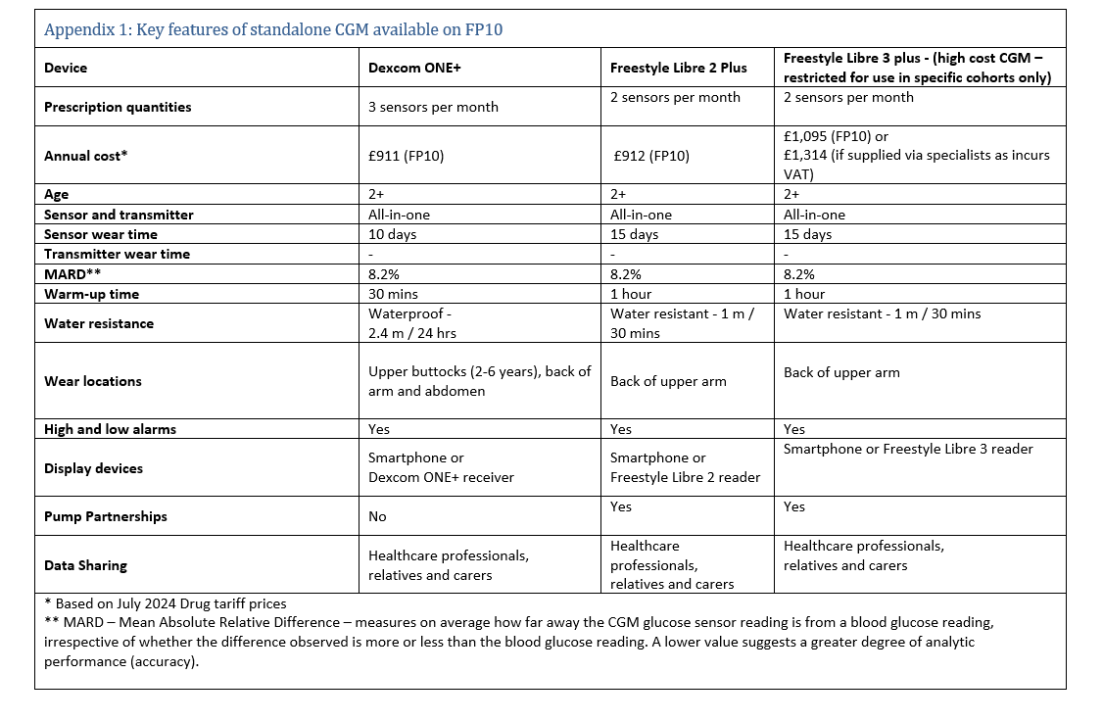
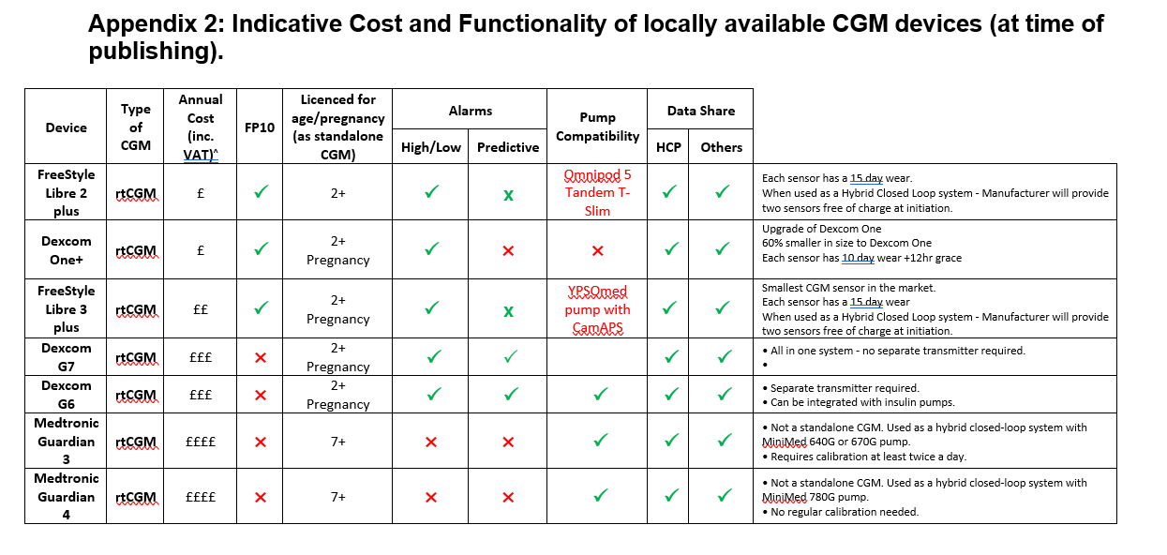
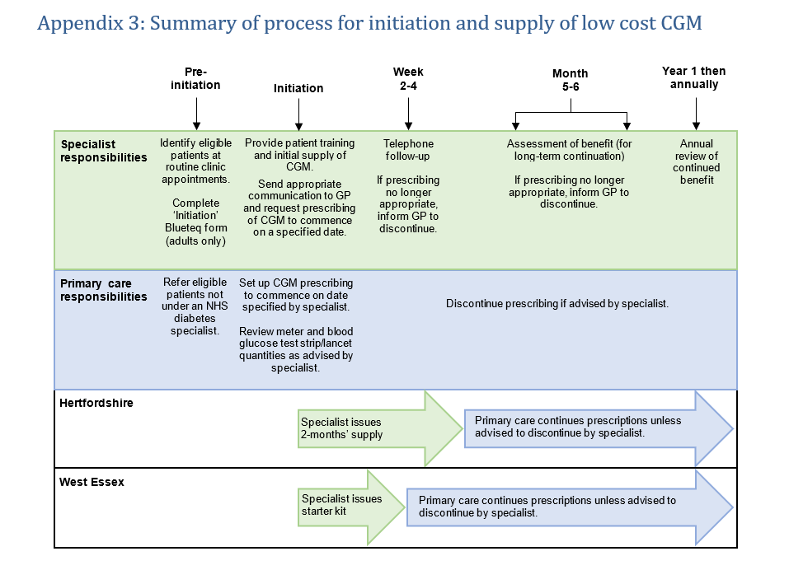

Appendix 4: Frequently Asked Questions for low cost CGM
1. Replacing faulty sensors/transmitters or sensors that fall off before they are due to be changed
If the sensor or transmitter is suspected to be defective or if the sensor falls off before it is due to be changed, patients should contact the manufacturer as soon as possible to obtain a replacement (see contact details below). Patients will need to keep the defective sensor/transmitter and follow the instructions given by the representative. Specialists/GPs should not issue additional prescriptions to replace defective sensors/transmitters or sensors that have fallen off.
Dexcom Technical Support Line
Tel: 0800 031 5763
Details of office opening hours can be found at: https://www.dexcom.com/en-gb/contact-us-direct
Abbott Customer Careline
Tel: 0800 170 1177
Details of office opening hours can be found at: https://freestylediabetes.co.uk/contact-us
Medtronic Product/technical support
Tel: 01923205167
Support can be provided through their app.

2. Quantities of blood glucose test strips/lancets
Patients who use CGM still need to take blood glucose measurements, but less often. Blood glucose monitoring is required to check the accuracy of their CGM device and as a backup when blood glucose levels are changing quickly, or the device stops working. When CGM is commenced, prescribed quantities of blood glucose test strips/lancets should reduce. For further information, please see Guidance for Self-monitoring of Blood Glucose (SMBG) in patients with Diabetes Mellitus

3. Using CGM to monitor blood glucose levels for the purpose of driving
The Driver and Vehicle Licensing Agency (DVLA) has published guidance relating to the use of CGM to monitor blood glucose levels for the purpose of driving – click here to access the guidance
Version control
V3.1 March 2026: Following review by HWE ICB Diabetes Technology Group document type designated as Position statement and removal of references to policy.

