Discontinuation of Levemir (insulin detemir) – Local Guidance for Hertfordshire and West Essex

Summary key messages
- Do not initiate any new patients on any Levemir® products
- All existing patients on any Levemir® products require review and appropriate and safe switch to an alternative insulin by Dec 2026
- Switching must only be undertaken by healthcare professionals who are competent in the management of insulin in those living with diabetes. The guidance contained within this document is not intended to replace individual clinical decision making.
- The Specialist Pharmacy Service Medicines Supply Tool should be used for the latest updates on supply of the named alternatives.
- Refer to Appendix 1 for alternative insulin comparison, Joint clinical guidance from the Primary Care Diabetes & Obesity Society and the Association of British Clinical Diabetologists & additional supporting information below on switching in adults with Type 2 diabetes
- Refer to Appendix 2 for information on importing and running searches on GP clinical systems EMIS and TPP SystmOne.
- Clinicians should aim to diversify prescribing across available options where possible to reduce supply risk

Background
Novo Nordisk will discontinue Levemir® (insulin detemir) in both Penfill® and Flexpen® forms, with UK supply ending by December 2026. This decision is based on global usage trends. This document supports system planning for the high volume of people on Levemir®, including those with type 1, type 2, type 3c (pancreatic), and gestational diabetes to switch to an alternative insulin.

Medicines Safety Notification (MSN)
A MSN was published in June 2025 to advise clinicians NOT to initiate any new patients on any Levemir® products.
The MSN was updated in August 2025 to include Joint clinical guidance from the Primary Care Diabetes & Obesity Society and the Association of British Clinical Diabetologists to support clinicians in switching patients currently prescribed Levemir to alternative insulins.

Local Planning
Local teams with representation from HWE ICB, primary care, community and secondary care specialist diabetes service have developed this system planning document. Local prescribing data was used to map and plan work. Local data will be tracked monthly to assess progress and implement any mitigation measures.

Patient Numbers
Local data suggests the following number of patients in HWE by age band, place and diabetes type (according to GP read code) will require switching:
 | PATIENTS ON LEVEMIR
 | SOUTHWEST HERTS (SWH) |  |  | EAST AND NORTH HERTS (ENH) |  |  | WEST ESSEX (WE)
 | T1DM | T2DM | OTHER/UNKNOWN | T1DM | T2DM | OTHER/UNKNOWN | T1DM | T2DM | OTHER/UNKNOWN
AGE BAND
AGE 1-18 | 119 | 0 | 9 | 8 | 0 | 0 | 22 | 1 | 4
AGE 19+ | 859 | 247 | 286 | 262 | 122 | 96 | 225 | 169 | 123
Total | 978 | 247 | 295 | 270 | 122 | 96 | 247 | 170 | 127

Table 1: Patient groups and agreed local review and switch plan

Levemir® should not be initiated for new people living with diabetes from July 2025.
Diabetes Type on Levemir | Action and responsibility for review and switching
Any type of diabetes in pregnancy | All existing patients are under specialist clinics and specialist team undertake ongoing reviews and will maintain on Levemir throughout pregnancy or switch to an alternative if clinically indicated.  Patients will be reviewed at the end of the pregnancy. Where there is ongoing postnatal need for a long-acting insulin patients will be switched to an alternative by the specialist team.
Paediatric diabetes of any type (Type 1, Type 2, Type 3c, cystic fibrosis related diabetes [CFRD]) under 19 years old. | All patients should be under the care and regular follow-up by paediatric diabetes services.  To be reviewed by paediatric secondary care services at the patient's next routine appointment and undertake switch to alternative treatment option.
Adults with Type 1 diabetes, type 3c [Pancreatic) diabetes or cystic fibrosis related diabetes (CFRD) | SWH and ENH Place  All patients should be under the care and regular follow-up by adult diabetes services.  To be reviewed by the patient's usual adult diabetes services (community / secondary care) at their next routine review appointment and undertake switch to alternative treatment option.  WE Place  Patients on Patient-Initiated Follow-Up (PIFU) pathway should be advised by GP to contact the relevant service. These patients and patients who are already under the care and regular follow-up by adult diabetes services to be reviewed by the patient's usual adult diabetes services (community / secondary care) at their next routine review appointment and undertake switch to alternative treatment option.
Adults with Type 2 diabetes on Levemir insulin | Patients likely under care of primary care and may not be under specialist follow-up.  Primary care - where there is competency in insulin management and to switch Levemir to another appropriate insulin (with dose adjustment accordingly) - to be reviewed at the patient's next routine appointment and undertake switch to alternative treatment option. Clinicians may seek advice and guidance from local specialists as needed  Primary care - where there is not competency in insulin management and to switch Levemir to another appropriate insulin. Clinicians to either seek advice and guidance from local specialists to support appropriate and safe switch or refer to specialist care for review and to switch Levemir to another appropriate insulin (with dose adjustment accordingly). The following information should be provided to the community diabetes service:  - Recent HbA1c (within the last 3 months).  - Ensure patient is undertaking capillary blood glucose (CBG) at least four times daily (before meals and before bed), and ketone monitoring (where appropriate). Share results with the diabetes team and ensure patient is continuing to monitor.  - Share relevant information risk for instability, some of which includes - impaired hypoglycaemia awareness, history of severe hypoglycaemia or recurrent diabetic ketoacidosis, evidence of lipohypertrophy at injection sites, frailty &/or older age, renal or severe hepatic impairment, cognitive or functional impairment, learning difficulties or low health literacy, those with visual impairment & manual dexterity problems, high alcohol intake or binge drinking, high level of physical activity.

Clinical guidance for switching
Clinicians should refer to Appendix 1 for alternative insulin comparison, the Joint clinical guidance from the Primary Care Diabetes & Obesity Society and the Association of British Clinical Diabetologists and additional supporting information below on switching in adults with Type 2 diabetes for GP Practices to review and switch patients currently prescribed Levemir to alternative insulins.

Patients should be provided with appropriate counselling, information and training including: to use up existing insulin before switching; advise on new insulin, device, dose and titration; contact details if any concerns or adverse effects; review and follow-up arrangements
Specialists to provide appropriate information to primary care following switch to include: to remove Levemir from repeat; new insulin name, brand, strength, device and quantity to add to repeat; assurance of counselling and information given to patients; specialist contact details if any issues or concerns; review and follow-up arrangements by specialist team.

Searches for Primary Care.
Searches have been created for primary care. See Appendix 2 for information on how to import and run the searches on EMIS and SystmOne. There are three searches. The searches will help identify patients on Levemir with Type 1 diabetes, Type 2 diabetes and those who have either not been read coded or are read coded as Type 3c, gestational diabetes or CFRD. These will be in the ‘diabetes not recorded group’. Practices will need to review the ‘Diabetes not recorded group’ and read code the patients. The above process will help segment the patients into the groups highlighted in table 1 above. Practices should thereafter follow the advice in table 1 for review of each of these groups.

Supporting information on switching in adults with Type 2 diabetes for GP Practices
• Clinical review by a competent clinician is essential before switching to an alternative insulin. Switching must only be undertaken by healthcare professionals who are competent in the management of insulin in those living with diabetes.
• No basal insulin analogue is licensed for twice-daily use like Levemir®, so alternatives will need consideration, close monitoring, and adjustment.
• Monitoring should rely on capillary blood glucose (CBG) at least four times daily (before meals and before bed), and ketone monitoring (where appropriate)—not HbA1c alone, due to its historical nature.
• People with allergies to alternative insulins should be referred to local allergy or diabetes services as required.
• Use the table in Appendix 1 as a guide on product availability and choice. The guide will be updated if any availability changes. Clinical teams can check product availability via the DHSC Medicines Supply Notification and the Specialist Pharmacy Service Medicines Supply Tool (requires registration with a nhs.net address). Insulin Glargine U100, Semglee (check stock availability in appendix 1) and Lantus should be considered as preferred choices if clinically appropriate.
• Risk of glucose instability is elevated during insulin changes. A clinical review with CBG data is essential. There are patient groups who are higher risk for instability, some of which include: impaired hypoglycaemia awareness, history of severe hypoglycaemia or recurrent diabetic ketoacidosis, evidence of lipohypertrophy at injection sites, frailty &/or older age, children & adolescents, renal or severe hepatic impairment, high glucose variability, cognitive or functional impairment, learning difficulties or low health literacy, those with visual impairment & manual dexterity problems, high alcohol intake or binge drinking, high level of physical activity.
• As part of the clinical review, assess whether the current insulin regimen in type 2 diabetes could be optimised by introducing / switching to different insulin types (e.g., rapid-acting, or mixed insulin) or by incorporating non-insulin therapies.
• Utilise the information in the Joint clinical guidance from the Primary Care Diabetes & Obesity Society and the Association of British Clinical Diabetologists. Including algorithm (page 5) of alternative insulin options and worked examples page 14 to 19.
• When switching between insulins, there can be differences between absorption, potency, and action profile, therefore consider reducing doses by 10-20% to avoid the initial risk of hypoglycaemia.
• Ensure any change in device type is explained to the patient with written product information provided (insulin “credit cards” / passports / booklets).
• For those with very erratic glucose levels, or disproportionately high insulin doses, assess injection technique & check for lipohypertrophy at injection sites.
• If lipohypertrophy is detected, considerable dose adjustment is often required when changing injection sites, Local specialist advice is to consider reducing insulin by 20% if using new sites to prevent hypoglycaemia. Seek advice and guidance as necessary if unsure.
• Education & support should be provided to help individuals self-adjust doses post-switch, where appropriate, along with a check of understanding of sick day rules.
• Ensure adequate safety netting, advise patients to report any issues or concerns including about glucose levels after following provided dose adjustment guidance.
• People living with diabetes should be reviewed at 2-3 weeks to support with dose titration, as necessary. For those at higher risk of dysglycaemia aim for close clinical review within 1-2 weeks of change where possible.
• If there is uncertainty seek advice and guidance or refer to community / specialist diabetes services as per locally agreed pathways.

Advice and Guidance, and Referral Information
Contact details for the diabetes team
Please write ‘For Levemir Switch’ on referrals.

South and Wests Herts - Herts Valleys integrated diabetes service (HIDS):
Community Diabetes Specialist Service
Sandridge Gate, Ronsons Way,
St Albans AL4 9XR
Telephone: 01727 732073
Email: hids.diabetes@nhs.net

Acute (HIDS) service:
Michael Clements Diabetes centre
Watford General Hospital, Vicarage Road,
Watford, Herts. WD18 0HB
Telephone: 01923 244 366
All referrals to the HIDS team should be made through ERS using SPOC form.

East and North Herts - HCT Community Diabetes Service
Tel: 0300 123 7571
Email: HCT.CommunityENDiabetes@nhs.net
All referrals to the HCT Community diabetes service should be made through ESR.

East and North Herts - Acute Diabetes Service
Acute patient advice line: 01438 288 301
E-mail: diabetes.enh-tr@nhs.net

West Essex Community Diabetes Service
Telephone to leave messages: 01992 938462
Email: epunft.wex.communitydiabetes@nhs.net
Refer via Care Co-ordination Centre: epunft.carecoordinationcentre.west.2023@nhs.net

Appendix 1 – Alternative Insulins for SWITCHING and Supply Overview
- Local specialists agree that standard strength insulin (U100) should be utilised for switches from Levemir.
- MSN guidance advises that local plans should aim to diversify prescribing across available options to reduce supply risk where possible.
- The table below shows options available. Insulins highlighted in grey are unable to support switching plans. Choice of product should be based on clinical appropriateness, lowest cost product to be used where more than one product is clinically appropriate.
- Pre-filled pens choices in cost order are 1) Semglee U100 (Insulin glargine bio-similar) -check stock availability below, 2) Lantus U100 (insulin glargine).
- Cartridges with re-usable pen device choices in cost order are 1) Lantus U100 (insulin glargine), 2) Tresiba U100 (insulin degludec).
- Where patients require dose increments in 0.5 units consider Tresiba U100 cartridges with compatible re-usable pen device. See local guidance on re-usable insulin pen devices for further details.

Insulin type |  |  |  | Supply Overview
Insulin | Brand name, device type | Annual cost of 30 units a day | Re-usable pen for cartridges | Stock status | Ability to support increased demand (switches)
Human Isophane Insulin U100 (intermediate acting) | Humulin I Pre-filled pens (KwikPen) [Pack size 3ml*5 = £21.70] | £158.41 | N/A | In stock | CANNOT SUPPORT
Human Isophane Insulin U100 (intermediate acting) | Humulin I Cartridges [Pack size 3ml*5 = £19.08] | £139.28 | HumaPen Savvio (1-60 units) =£4.50 | In stock | CANNOT SUPPORT
Insulin Glargine U100 (Long acting) | Semglee Pre-filled Pens [Pack size 3ml*5 = £29.99] | £218.99 | N/A | In stock | Can support
Insulin Glargine U100 (Long acting) | Lantus Pre-filled pens (Solostar) [Pack size 3ml*5 = £34.75] | £253.68 | N/A | In stock | Can support
Insulin Glargine U100 (Long acting) | Lantus Cartridges [Pack size 3ml*5 = £34.75] | £253.68 | AllStar PRO (1-80 units) = £8.33  JuniorSTAR (1-30 units) [dose increments in half units] = £13.00 | In stock | Can support
Insulin Glargine U100 (Long acting) | Abasaglar Pre-filled pens (KwikPen) [Pack size 3ml*5 = £35.28] | £257.54 | N/A | In stock | CANNOT SUPPORT
Insulin Glargine U100 (Long acting) | Abasaglar Cartridges [Pack size 3ml*5 = £35.28] | £257.54 | HumaPen Savvio (1-60 units) =£4.50 | In stock | CANNOT SUPPORT
Insulin Degludec U100  (Ultra Long acting) | Tresiba Pre-filled pens U100 (FlexTouch) [Pack size 3ml*5 = £46.60] | £340.18 | N/A | CANNOT SUPPORT BEING DISCONTINUED
Insulin Degludec U100  (Ultra Long acting) | Tresiba U100 Cartridges [pack size 3ml*5 = £46.60] | £340.18 | NovoPen 6 (1-60 units) = £5.37  NovoPen Echo Plus (0.5-30 units) [dose increments in half unit] = £5.37 | In stock | Can support
Insulin Detemir U100 | Levemir Pre-filled pen (Flexpen) [Pack size 3ml*5 = £42.00] | £306.60 | N/A | Product being discontinued. Do NOT initiate any new patients. Switch existing patients in line with local plan
Insulin Detemir U100 | Levemir Cartridges [Pack size 3ml*5 = £42.00] | £306.60 | NovoPen 6 (1-60 units) = £5.37  NovoPen Echo Plus (0.5-30 units) [dose increments in half unit] = £5.37

High Strength Insulins
- Not routinely recommended for use in Levemir switch plan. Levemir only available in U100 strength therefore, patients in the switch programme unlikely to require high strength insulins. Switches to higher strength insulins may add additional risks concerning dose conversion, units & dose confusion / errors.

HIGH STRENGTH Insulin type |  |  |  | Supply Overview
Insulin | Brand name, device type | Annual cost of 30 units a day | Re-usable pen for cartridges | Stock status | Ability to support increased demand (switches)
Insulin Glargine U300 (Ultra Long acting) | Toujeo U300 Pre-filled Pens (SoloStar) [Pack size 1.5ml*3 = £32.14] | £260.69 | N/A | In stock | Can support
Insulin Glargine U300 (Ultra Long acting) | Toujeo U300 (DoubleStar) [Pack size 3ml*3 = £64.27] | £260.65 | N/A | In stock | Can support
Insulin Degludec U200  (Ultra Long acting) | Tresiba pre-filled pens U200 (FlexTouch) [Pack size 3ml*3 = £55.92] | £340.18 | N/A | In stock | Can support

Appendix 2 – Searches for GP practices

2.1 Levemir Searches – For EMIS PRACTICES

Instructions for importing searches into EMIS
Download the Levemir FlexPen + Penfill (DHSC).xml file, then open EMIS.

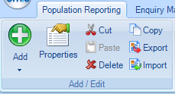
Click on Import:

Select the downloaded file as Enquiry Document, then click on OK to import:
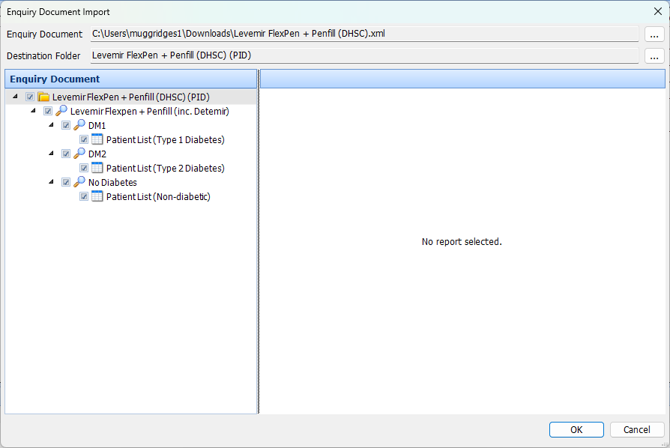
The searches will be imported to the Levemir FlexPen + Penfill (DHSC) (PID) folder.

Instructions for running the Levemir searches in EMIS
All of the searches in the Levemir FlexPen + Penfill (DHSC) (PID) folder can be triggered together by right-clicking on the folder and choosing Run from the menu:
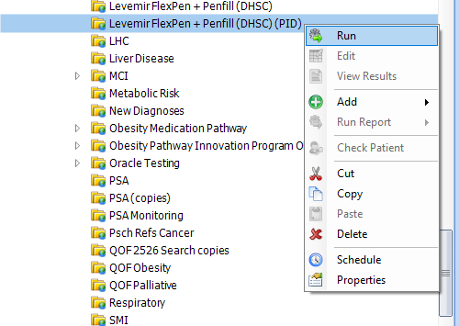
When the searches are complete, each of the reports can be viewed and exported
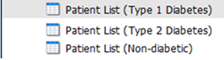
Select the desired report:

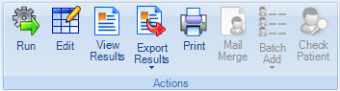
and click on the View Results button:

This will display a copy of the complete report, which can be reviewed or exported:
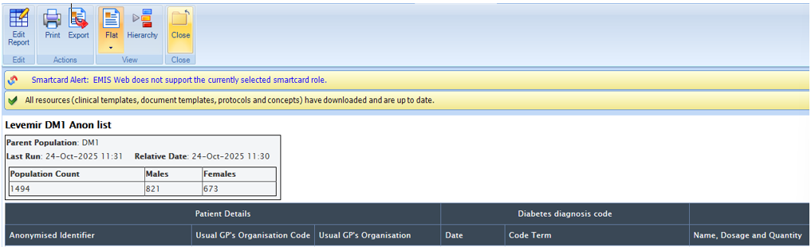

2.2 Levemir Searches for SystmOne practices

Instructions for importing searches into SystmOne
Download the Levemir FlexPen + Penfill (DHSC).rpt file, then open SystmOne.


Open the Reporting section, and then select Import:

Select the downloaded file when prompted, and SystmOne will import the searches into a folder named Levemir.
Navigate to Levemir folder, and then run each of the following searches by selecting each search and clicking on the run button ( ):
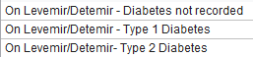
There are other searches in the folder, each marked “xxx” – these will run as required when the three searches above are run.
After each search completes, it is necessary to breakdown the results for export. Select each search and click on the Breakdown button ( ) .
Select the relevant fields in the left pane, then click on
Recommended fields are:
- On Levemer/Detemir – Diabetes not recorded / Type 1 Diabetes / Type 2 Diabetes
  - Strategic Reporting ID
    - Patient ID
  - Demographics
    - Age
  - Registration
    - Registered Practice
- xxxDM1 / xxxDM2
  - Coded Entries
    - Read code description
  - Event Details
    - Event date
- xxxSubreport | Prescribing | Levemir – issue with end date after today
  - Issues
    - Drug
  - Event Details
    - Event date
This will display the patient details in the right pane, which can then be exported ( ) or printed ( ) .

The guidance contained within this document is not intended to replace individual clinical decision making by healthcare professionals who are competent in the management of insulin in those living with diabetes.
The Specialist Pharmacy Service Medicines Supply Tool should be used for the latest updates from DHSC on the supply position of the named alternatives
Local plans should reflect that clinicians should aim to diversify prescribing across available options to reduce supply risk where possible
Version | VERSION 4.0 – 12/05/2026  Updates as agreed by task and finish group on 28/04/2026  - Update to Table 1 - In adults with type 2 diabetes on Levemir - Clinicians in primary care where there is not competency in insulin management and to switch Levemir to another appropriate insulin – Remove – “need to wait till the month of birth of the patient to either seek advice and guidance from local specialists.”  - Update to Table 1 – Remove “Hertfordshire Integrated Diabetes Service may also contact practices with 5 or more eligible patients with Type 2 diabetes on Levemir offering the option of virtual MDT to support switching. The service will contact the relevant practice/s to arrange mutually convenient date/time and confirm process and information required.” – Option of virtual MDT retired - All referrals for eligible patients to the HIDS team should be made through ERS using SPOC form.  VERSION 3.0 – 06/03/2026  - Levemir FlexPen + Penfill (DHSC).rpt file added to support with searches on SystmOne  - Manufacturer and SPS update (2nd March 2026) - Semglee® now back in stock.  VERSION 2.0- 30/01/2026  - Saved as word version as contains an embedded file to support with EMIS searches)  - Stock Update on 30/01/2026 – Limited stock of Semglee®. Manufacturer expects this to resolve mid-February 2026.  - Levemir FlexPen + Penfill (DHSC).xml file added to support with searches on EMIS  VERSION 1.0 – 9/12/2025.  - Stock Update on 12/12/2025 – Limited stock of Semglee®. Manufacturer expects this to resolve in January 2026.
Developed and approved by | Task and Finish group for Levemir discontinuation. HWE ICB representatives (including pharmacy team and Associate Medical Director/ Public Health Consultant), primary care (GP leads for diabetes and long-term conditions), community diabetes services (HIDs, HCT, EPUT) and secondary care specialist diabetes services (WHHT, ENHT, PAH).
Date approved/updated | Version 1.0 Approved at Task and finish group 9/12/2025. Last updated to version 4.0 on 12/05/2026.
Review date: | The recommendation is based upon the evidence available at the time of publication. This recommendation will be reviewed upon request in the light of new evidence becoming available.

